NAME: RAJNANDINI KANDIKATLA

COLLEGE: NAGESH KARAJGI COLLEGE OF ENGINEERING AND TECHNOLOGY

BRANCH: COMPUTER SCIENCE &TECHNOLOGY

YEAR-SEM: 3-1

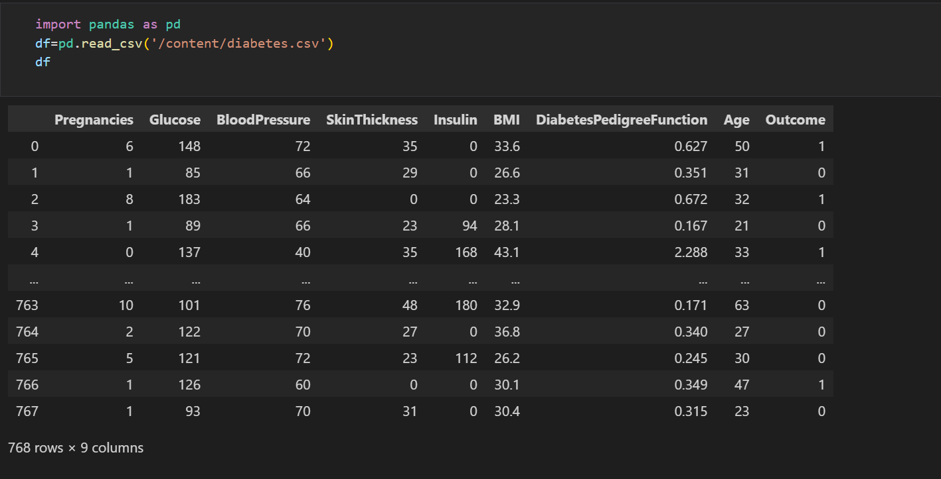

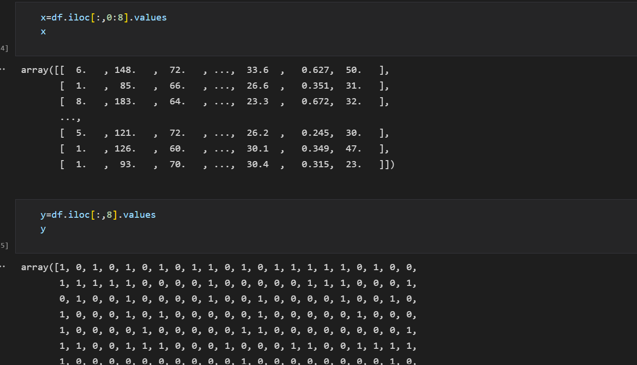

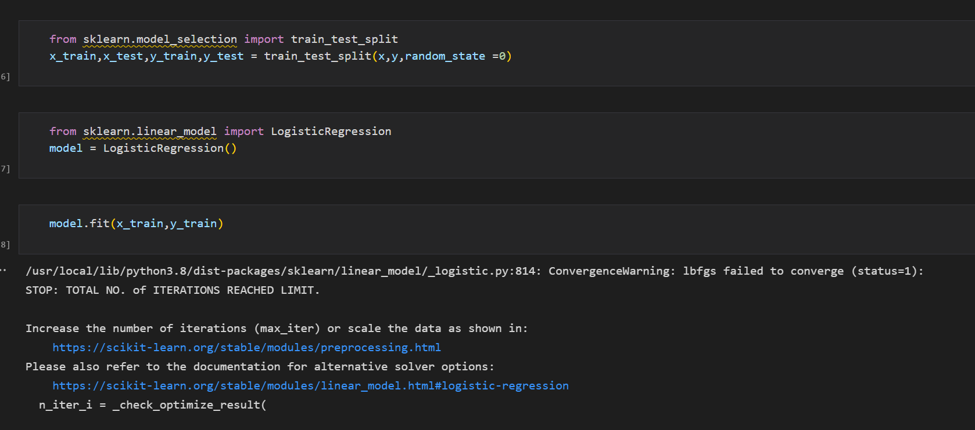

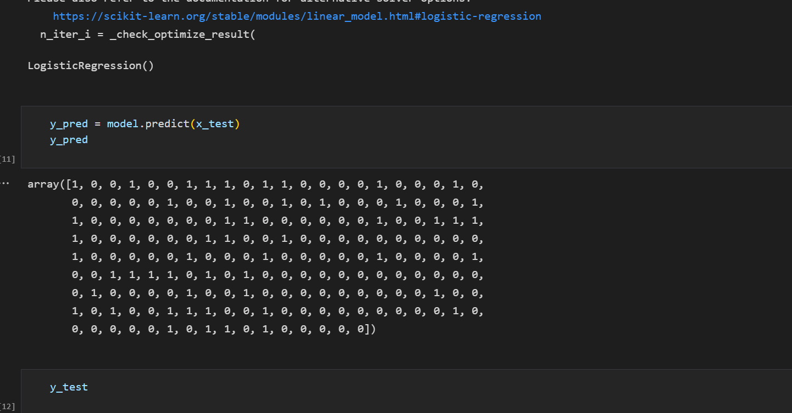

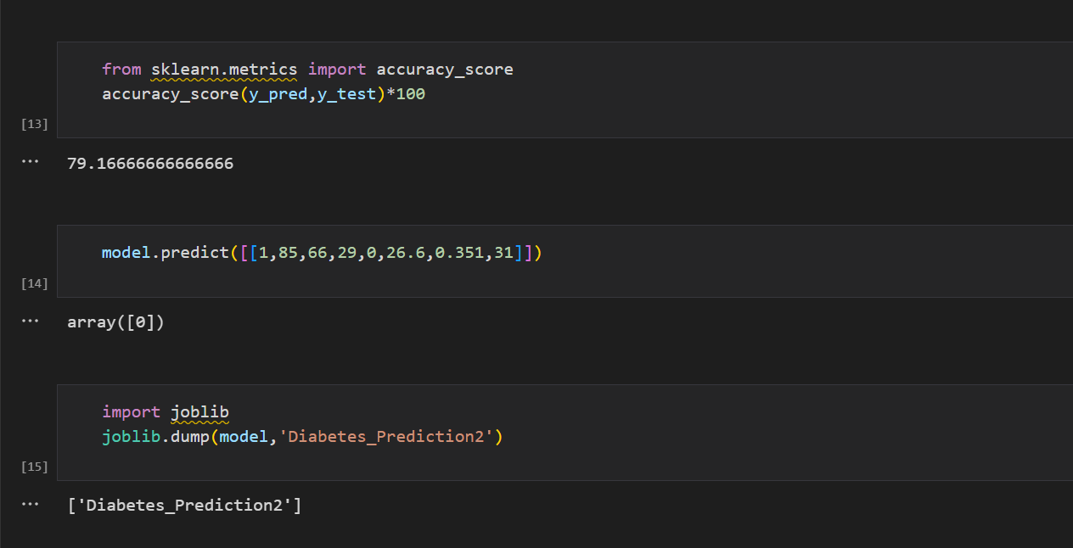

DATASET URL-<https://www.kaggle.com/c/diabetes-prediction/data>

GOOGLE COLLAB NOTEBOOK-<https://colab.research.google.com/drive/1mQ8zz8aGCAxHxKBFzjLxKUwJIdkGYlYK?usp=sharing>